PROJECT DESIGN PHASE-II
DATA FLOW DIAGRAMS & USER STORIES
Project Name: | BlogNest API
Team ID: | SWTID-2026-4160
Date: | 30 September 2026
Maximum Marks: | 4 Marks

1. Project Overview
BlogNest API is a secure, AI-assisted blogging backend built with Node.js, Express.js, MongoDB, and Mongoose. It supports user authentication with JWT, role-based access for Admin, Editor, Author, and Reader, blog post management, comments and moderation, categories and tags, media metadata, search, reporting, AI blog generation, and content summarization. API requests are validated and processed by the server before data is read from or written to MongoDB.

2. Data Flow Diagrams (DFD)
The diagrams below adapt the template to BlogNest API. They show the main external entities, processes, data stores, and data movement described in the project document.
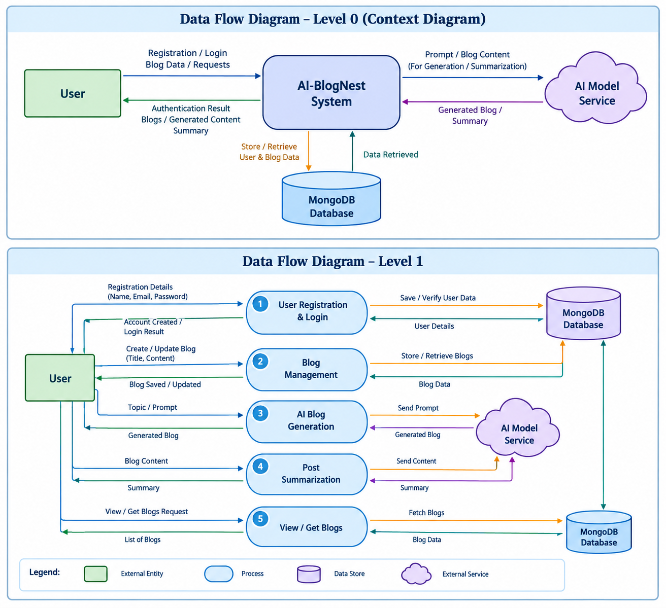

2.1 Context Diagram (Level 0)
External Entity: Reader / Author | → HTTPS/JSON API Requests → | BlogNest API System
External Entity: Editor / Admin | → Authenticated Requests → | BlogNest API System
External Service: Google Gemini AI | ←→ Prompt / Generated Content → | BlogNest API System
Main outputs: JSON responses, authentication tokens, blog content, comments/status updates, AI-generated drafts and summaries. Persistent records are stored in MongoDB.

2.2 Level 1 DFD — Main API Processes
Process / Data Store | Data flow / responsibility
1.0 API Gateway & Validation | Receives HTTP requests; parses JSON; validates and sanitizes input.
2.0 Authentication & Role Authorization | Checks login credentials, validates JWT, and enforces Admin/Editor/Author/Reader permissions.
3.0 Blog & Taxonomy Management | Creates, retrieves, updates, and deletes permitted posts; manages categories, tags, and media references.
4.0 Comment Management | Creates comments and lets authorized roles moderate comment status.
5.0 AI Content Services | Sends prompts/content to Google Gemini AI for blog generation or summarization.
6.0 Search & Reporting | Processes search/filter requests and returns permitted post-performance information.
D1 MongoDB — Users | User profile, email, hashed password, role.
D2 MongoDB — Posts | Post title/name, content/message, author userID, photo path, likes, timestamps, status and related metadata.
D3 MongoDB — Comments & Taxonomy | Comment records, categories, tags and moderation information.

2.3 Main Data Flows
- Reader / Author / Editor / Admin → API Gateway: HTTP method, route, headers, JWT (when required), and JSON payload.
- API Gateway → Authentication & Authorization: credentials or token and requested action; middleware returns verified identity and role or an error.
- API processes ↔ MongoDB data stores: validated user, post, comment, category, tag, media metadata, and reporting data.
- Blog/AI request → Google Gemini AI service: prompt or source content; AI service → API: generated blog text or summary.
- API Gateway → caller: JSON data, success status, validation message, authorization error, or structured server error.

3. User Stories
Acceptance criteria describe observable API behavior and can be checked with Postman or Thunder Client. Sprint and priority values are proposed planning values for this adapted template.
User Type | Functional Requirement (Epic) | User Story Number | User Story / Task | Acceptance Criteria | Priority | Release
Reader / User | User Registration | USN-1 | As a user, I can register by providing my name, email, and password. | A user record is created with a unique email; the password is securely hashed; invalid or missing fields return validation errors. | High | Sprint 1
Reader / User | Authentication | USN-2 | As a registered user, I can log in with my email and password. | Valid credentials return a JWT; invalid credentials are rejected; password values are never returned in the response. | High | Sprint 1
All authenticated roles | Authentication & Authorization | USN-3 | As an authenticated user, I can access protected API endpoints using my JWT. | A valid token is accepted; missing, invalid, or expired tokens are rejected; role restrictions are enforced. | High | Sprint 1
Author | Blog Management | USN-4 | As an author, I can create a blog post with a title, content, and optional photo path. | The post is saved with its author reference and timestamps; required fields are validated; only an authorized author can create it. | High | Sprint 1
Author | Blog Management | USN-5 | As an author, I can view and manage posts associated with my account. | The author can retrieve their posts; users cannot modify posts belonging to another author unless their role permits it. | High | Sprint 1
Reader / Public user | Blog Discovery | USN-6 | As a reader, I can retrieve published blog posts and view their content. | The API returns published posts in JSON; unavailable records return an appropriate response; private or unpublished content is not exposed publicly. | High | Sprint 1
Editor | Editorial Workflow | USN-7 | As an editor, I can review pending posts and update their publishing status. | Only an editor or admin can update status; accepted status values are validated; the updated record is returned. | High | Sprint 2
Admin | User & Role Management | USN-8 | As an admin, I can manage user roles and account permissions. | Only an admin can change roles; unsupported roles are rejected; successful changes persist in the database. | High | Sprint 2
User / Reader | Comment Management | USN-9 | As an authenticated user, I can add a comment to a blog post. | The comment is linked to the user and post; required text is validated; moderation status is assigned according to system rules. | Medium | Sprint 2
Editor / Admin | Comment Moderation | USN-10 | As an editor or admin, I can review and moderate comments. | Authorized roles can approve, mark pending, or mark spam; unauthorized requests are rejected; changes are saved. | Medium | Sprint 2
Author | AI Blog Generation | USN-11 | As an author, I can request AI-generated blog content from a topic or prompt. | The API validates the prompt; the AI service response is returned as structured content; service errors are handled safely. | High | Sprint 2
Author / Editor | AI Summarization | USN-12 | As a user with permission, I can request a concise summary of blog content. | The API accepts content, calls the summarization service, and returns a summary; invalid input and AI service failures return clear errors. | Medium | Sprint 2
Author | Categories & Tags | USN-13 | As an author, I can organize blog posts using categories and tags. | Valid category/tag values can be associated with posts; filtering requests return matching posts; invalid values are handled. | Medium | Sprint 3
Author / Admin | Media Metadata | USN-14 | As an authorized user, I can register or update media path metadata for a post. | The API validates the media reference; metadata is linked to the relevant post; unauthorized changes are blocked. | Low | Sprint 3
Author / Admin | Search & Reporting | USN-15 | As an authorized user, I can search blog content and review available post-performance information. | Search terms and filters are validated; matching records are returned; analytics are limited to permitted data. | Low | Sprint 3
All users | Error & Security Handling | USN-16 | As a user, I receive consistent error responses when an API request fails. | Validation, authentication, authorization, not-found, and server errors return structured JSON; sensitive details are not exposed; rate limits and sanitization are applied where configured. | High | Sprint 1

4. Assumptions / Notes
- Roles in scope: Admin, Editor, Author, and Reader, as described in the BlogNest API project document.
- Technology in scope: Node.js, Express.js, MongoDB, Mongoose, JWT, bcrypt.js, Postman/Thunder Client, and Google Gemini AI.
- Endpoints and specific field names should be confirmed against the implemented API. Where the source document does not specify exact routes or comment/category schemas, stories describe expected behavior rather than asserting an undocumented route.
- AI-generated content and summaries depend on availability of the external AI service; failures should be returned as structured API errors.

